# Recommendations on Electrifying Blue Bike Stations

Prepared by: Julie Compston, Jessie Finocchiaro, Katie Slyman (Boston College)

Last Updated: February 19, 2026

## Data

We used two datasets, both in the forms of CSVs downloaded from data.boston.gov.

1. Blue Bike ride data from October 2025.
   1. **Features**: Classic vs E-bike, Start time, End Time, Start Station, End Station, Lat/Lon Coordinates, Membership of Rider
   2. **Missing:** Charge information on E-bikes, Bike ID to track a specific bike’s path.
2. Station List as of November 17, 2025
   1. **Features:** Name, Lat/Lon Coordinates, Seasonal Status, Municipality, Number of Docks, Station ID
   2. **Missing:** Location of station on sidewalk vs street (seemed important in NYC)

## Initial Exploration of system usage

There is a heavy-tailed distribution on the total number of rides (classic or e-bike) that go to each station, and this follows similarly for just e-bike rides as well.

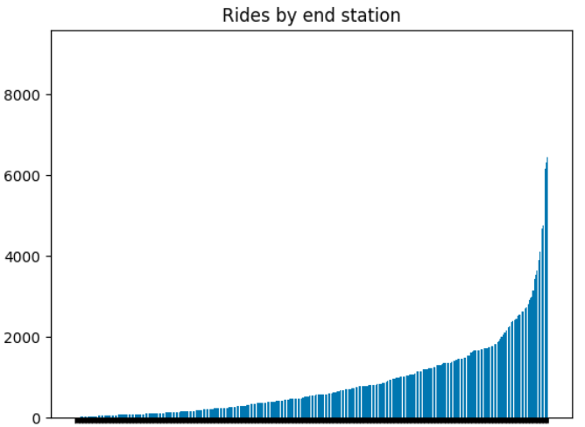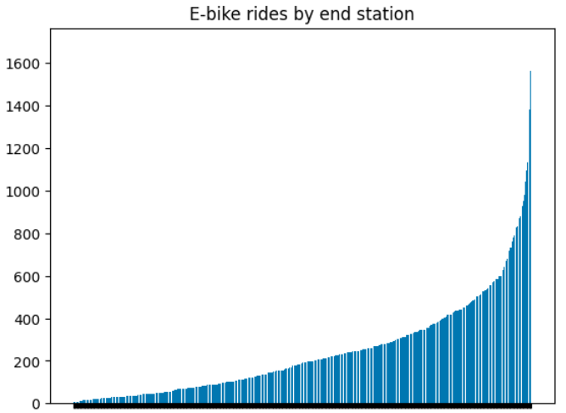

Some preliminary visualizations allude to a tension where high-traffic stations (larger radius of station) tend to have a lower ratio of e-bikes at the station (more blue coloration).

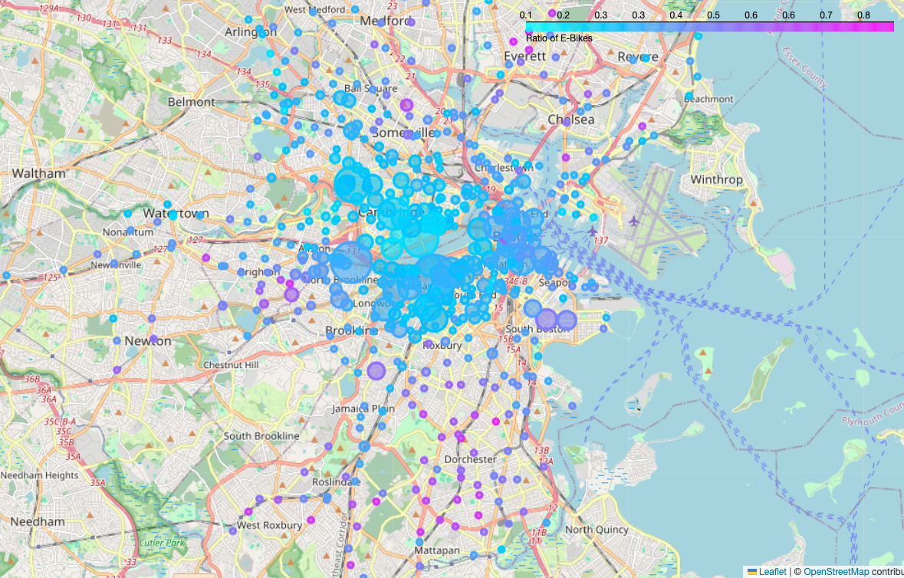

We apply a “suburban” mask on each station, deeming it suburban if it is more than 4 kilometers from the “mean” station, representing the center of population. We observe that the most e-bike concentrated stations tend to be suburban. In general, we also find that 36% of e-bike rides involve a suburban station. 64% of rides are urban-to-urban, 23% are urban-to-suburban or the reverse, and 13% of rides are suburban-to-suburban.

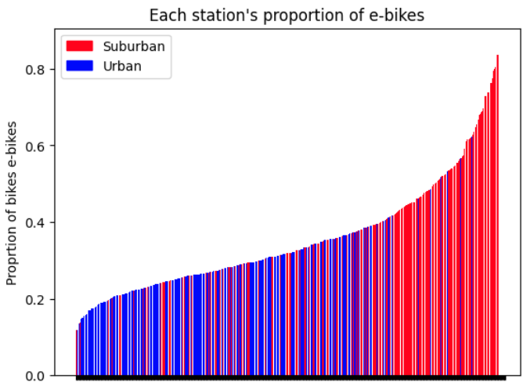

However, in thinking about charging bikes, we considered that it was not just important to understand how many bikes were at a station, but how long each e-bike was staying at the station. Because we didn’t have access to a bike ID number associated with each ride, we looked at a “worst-case” (least latent time) estimate for each station, where the bike that was just returned was the “next bike out.” [This article](https://www.curbed.com/article/citi-bike-battery-ebike-charging-docks-maintenance-repair.html#:~:text=(A%20full%20charge%20takes%20about,hours%2C%20like%20an%20EV.)) about NYC’s electrification of stations seems to suggest that 4-6 hours will be necessary to fully charge a bike. Even the least visited stations are shy of this full charging block, but that might be because of how conservative our estimate is.

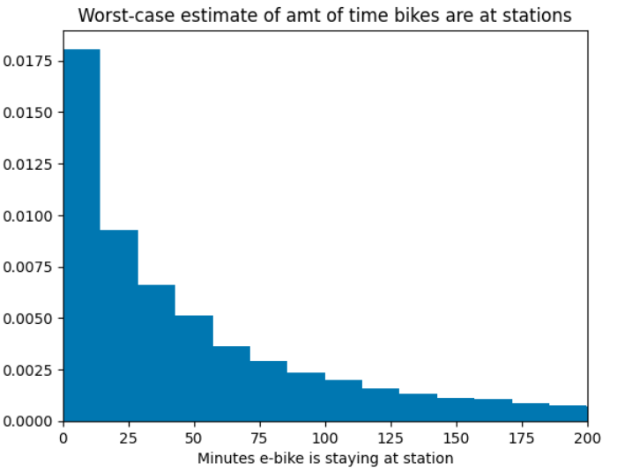

## Station usage

An initial exploration of some of the busiest stations led us to many of the universities. For example, one of the most common start-end pairs for rides with from Commonwealth Ave at Agganis Way to Commonwealth Ave at Granby St and back—presumably taking students from the residential to academic parts of Boston University. All the 10 most frequent trips are less than 2km apart (even less than a mile), which we try to control for in further analysis, since these rides presumably do not consume as much electricity and are lower stakes if a bike runs out of battery power.

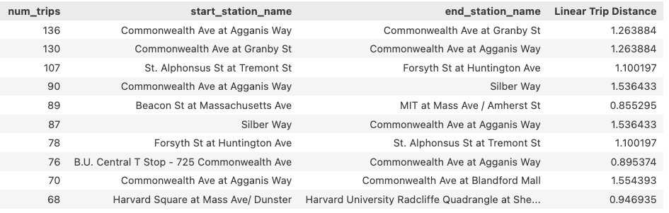

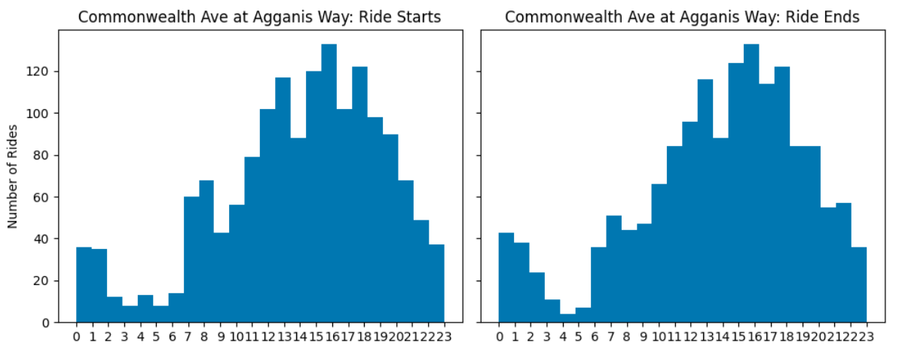

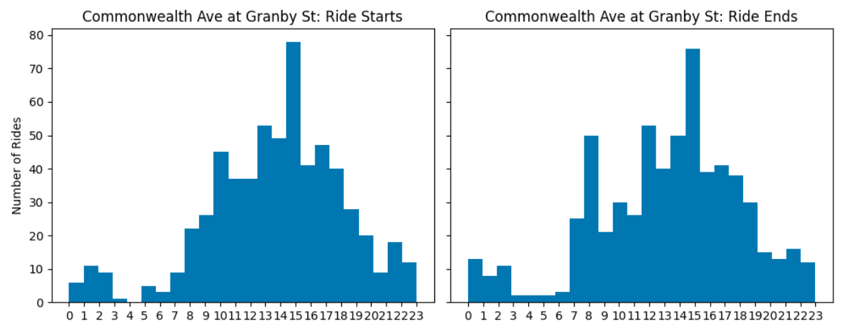

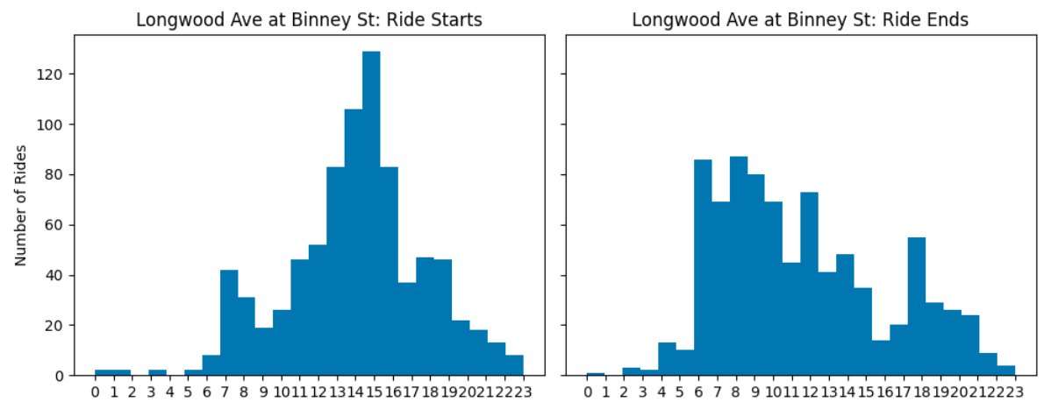

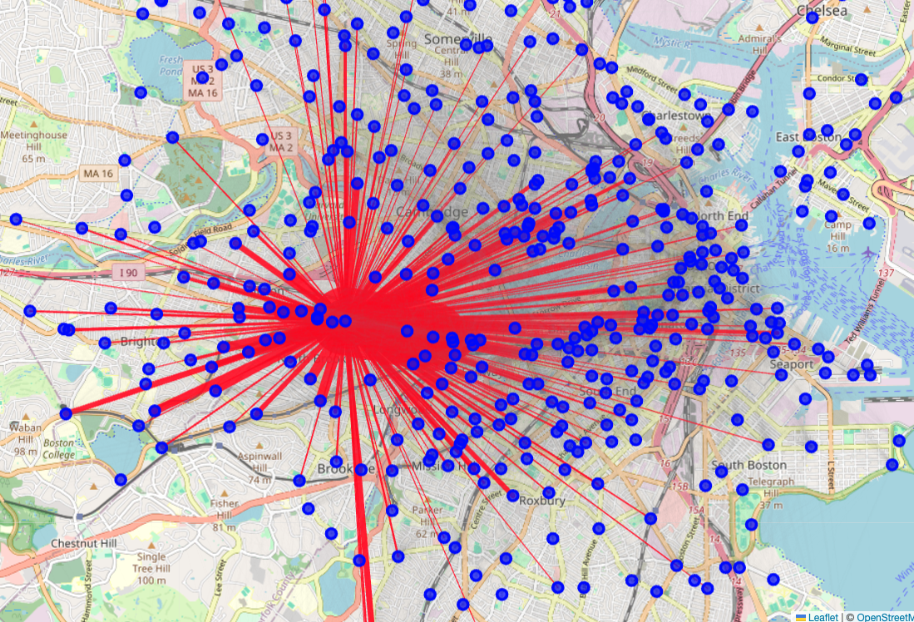

We also generated a graph of rides starting from give stations (above: Comm Ave at Agganis Way; below: Longwood Ave at Binney), weighted by how many rides end at each station. Longwood Ave at Binney is near the hospitals and seems to be a receptor of many suburban rides, presumably handling commutes from many employees.

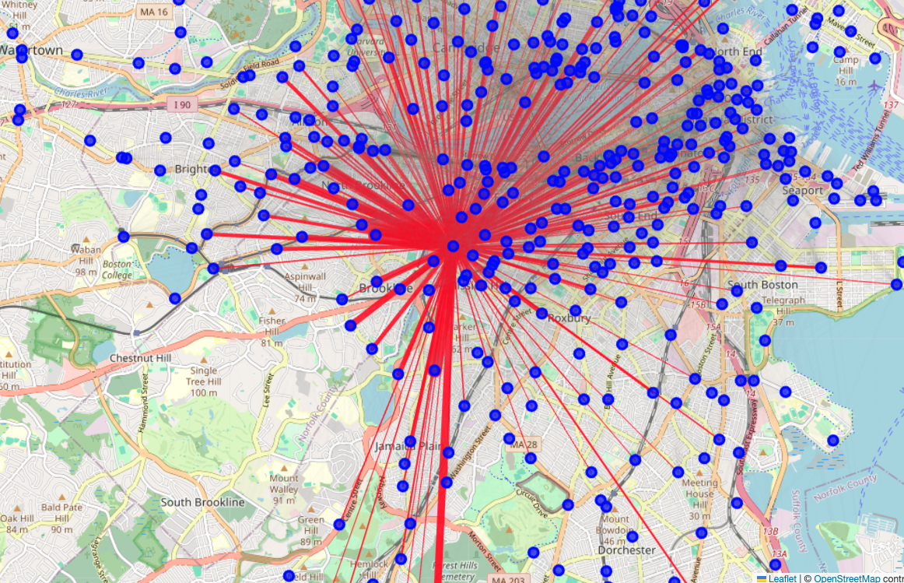

## Optimizing electrification

We consider a small suite of metrics to consider when looking at a set of stations to electrify.

### Utility metrics

A first naïve approach is to consider the most utilized stations and simply electrify those. However, as we observed in the initial exploration, these are often connected to each other, so electrifying a set of high-throughput, often-connected stations will likely have redundancies.

#### Charging Score

In reading the report that states e-bikes needs 4-6 hours for a full charge, we design a metric that rewards stations for timed use, where bikes are at least at the station long enough to get a significant partial charge.

The goal of this metric is to determine which stations balance high daytime usage with low nighttime usage or longer low-usage blocks to allow for adequate charging windows. For example, if the busiest station in Boston has bikes leaving every 5 minutes throughout the day, we expect charging will not actually be that useful. Let

$$N_{i}\left(t,Δ\right)≔\text{\#}\text{ of departures from station }i \text{in time window}\left[t,t+Δ\right)$$

where $Δ$ is a time interval amount to discretize time. Additionally, let $τ$ be a threshold for the number of departures in the window considered to be efficient. For example, if 15 bikes are leaving a station every 30 minutes, then bikes charging for 2 minutes (on average) is not very helpful. With this, we say that the total charging time available at station $i$ in the day is:

$$C_{i}\left(Δ,τ\right)≔\sum_{t}{1}\{N_{i}\left(t,Δ\right)\}⋅Δ$$

where the indicator function is equal to 1 if the number of departures in the window is below the threshold $τ$, representing a sufficient “charging block.” We then scale $C_{i}$ by the total station utilization to obtain a charging score. This score is highest when both downtime and the number of total departures is high. Observe that abnormally high station utilization might skew results, so we do check this later.

With $Δ$ being 30 minutes and $τ= 2$, we initially observe the following top-5 stations by charging score.

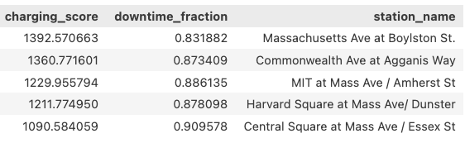

In trying to control charging score to be less skewed by high utilization, we incorporate min-max normalization on the downtime fraction and number of departures, and an interquartile range-based score to penalize very high concentration of bike use at a particular time of the day.

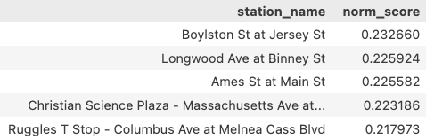

#### Restricting to longer trips

While it is natural to consider the charging score of stations when considering *all* trips, we also restrict our search to the set of trips that are at least 10 and at least 20 minutes, as we assume most short trips are not a substantial drain on the bike’s battery. See further discussion in the Takeaways section, but this simply serves as another robustness check.

### Fairness metrics

#### Max-Min

One “worst case” notion of fairness is considering the farthest distance a customer would have to travel to access an electrified station. Since we do not have customer locations, we use station locations as a proxy. Suppose there are $n$ stations, and we can electrify up to $k$ of them. Throughout, we generally use $k = 3$. The location of station $i$ is denoted $x_{i}$.

Max-min fairness is then defined by

$$\max_{i∈\left[n\right]}\left(\min_{j∈\left[k\right]}{d\left(x_{i},x_{j}\right)}\right)$$

Importantly, since there is a cluster of stations up in Salem, this metric inevitably requires a station in Salem be electrified. Including Salem, the tuple of stations (Seaport Blvd at Sleeper St, Coolidge Corner – Beacon St at Centre St, Salem State University – Bike Path at Loring Ave) best satisfies this notion of fairness, with a maximum distance of 10.53 kilometers needed to be traveled.

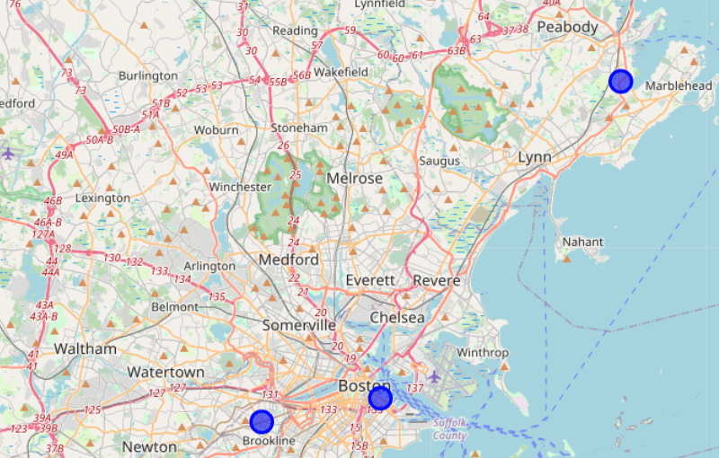

If we were to *exclude Salem* from this computation, then the tuple (Commonwealth Ave at Agganis Way, Forsyth St at Huntington Ave, Lewis Wharf at Atlantic Ave) becomes the most fair, with a maximum distance of 10.586km being the maximum distance necessary.

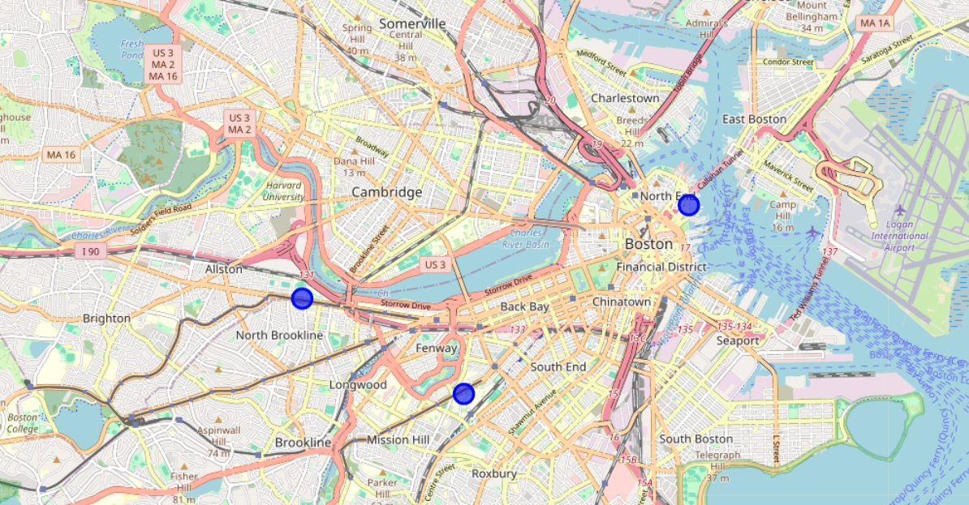

Observe that this notion of fairness leans heavily on one station to be the “closest”, so there are many station combinations that are “equally fair” according to this metric. When excluding Salem, it is most important to include the Commonwealth Ave at Agganis Way station.

#### Median-Min

Similarly, one can define median-min fairness as the average distance to the closest station of the three. We opt to use the median instead of the mean for robustness to outliers, where a station near the South End/Roxbury might look bad due to the number of stations in Roxbury.

### k-Medioids

As a naïve robustness check, we evaluate the recommendation that emerges from unsupervised methods like *k*-medioids, which yields the *k* stations minimizing the median distance over the cluster of other stations closest to this candidate.

With 3-medioids, we obtained recommendations of Canal St at Causeway St, Mass Ave at Boylston St, and Central Square at Mass Ave/Essex St. Notably, the latter two of these stations are at times recommended with different variants of the charging score.

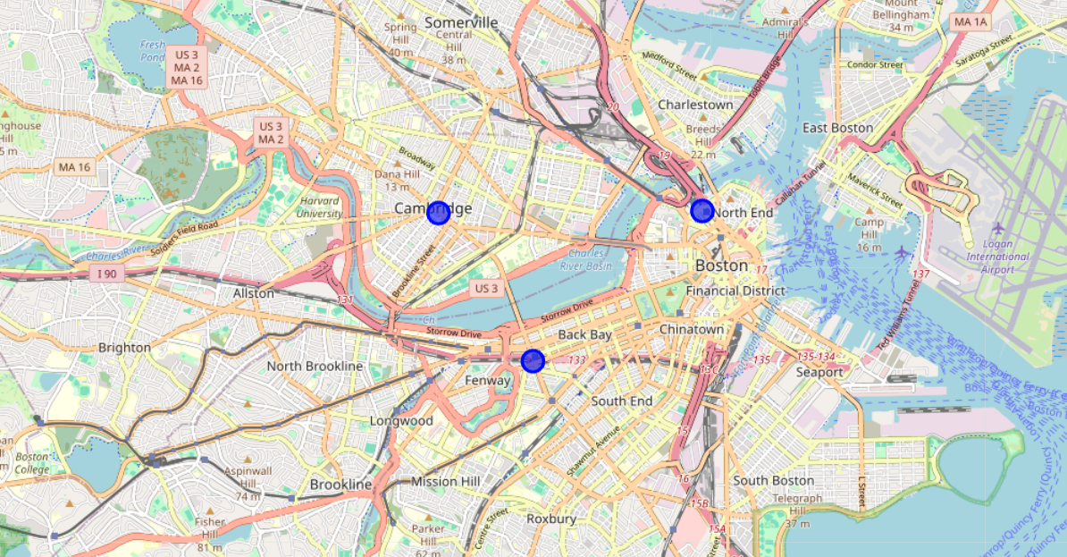

## Takeaways

In looking at charging score with a variety of hyperparameters, we see a handful of stations appear over many population combinations of scores. In varying (a) the set of trips to be (i) all ebike trips, (ii) those at least ten minutes, and (iii) at least twenty minutes, (b) the $Δ$ charging window parameter to be 30 minutes, 1 hour, 2 hours, or 4 hours, and (c) the $τ$“high usage" parameter to be 0, 1, or 2, we analyze the frequency a tuple of stations appears in the top 5 charging scores over these 24 parameter settings. The count column below relays how many times (out of 24) a specific combination of 3 stations was in the top 5 charging scores with a given set of parameters. The max_min_s1 column denotes the maximum distance from another station, where station 1 (respectively, 2 and 3) is the closest to the origin point. Distance is measured in kilometers. Similarly, med_min_s1 gives the median distance from one station to station 1, conditioned on station 1 being the closest of the three.

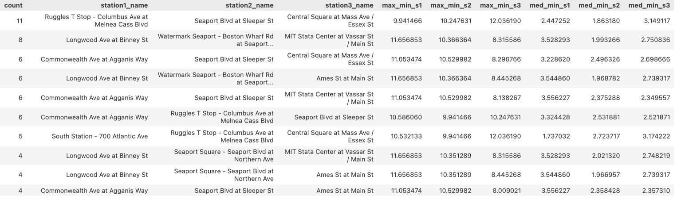

We briefly discuss a few common stations in these top-10 tuples.

* Ruggles T Stop – Columbus Ave at Melnea Cass Blvd
  + While this stop appears in its first tuple as a top performer 11 times, the majority of parameterizations occur when rides are only 20 minutes or longer. This indicates that users interact with the Ruggles T stop for longer trips, making it a good candidate for electrification.
  + Location right by both orange and green lines, aligns with our empirical observations that commuter rail riders and T commuters might use these bikes to get from the T to work.
  + This station has 26 docks, which is higher than many other candidate stations.
* Longwood Ave at Binney St
  + Notably, this station is close to the Ruggles T Stop, and the two do not appear in the same combination of stations.
  + This station is close the D and E lines of the green line.
  + Over visualization of spread and time-of-day use suggests a consistent population might use this station for work commutes. Since the spread of end stations is heavily concentrated, charged bikes may not disperse as widely.
  + 15 docks, which is ‘standard.’
* Seaport
  + While Seaport Blvd at Sleeper St is often a good candidate in terms of charging score, this is mostly because it is a few blocks closer to the rest of Boston than the other Seaport stations. However, it only has 15 docks.
  + In contrast, Seaport Square - Seaport Blvd at Northern Ave has 23 stations and is only two blocks farther than Seaport Blvd at Sleeper St.
* MIT Stata Center at Vassar St / Main St or Central at Mass Ave / Essex St or Ames St at Main St
  + Most often recommended Cambridge-based stations, but they are never recommended simultaneously. All three are close to red line stops.
  + MIT has 35 docks, Central has 19 docks, Ames has 19 docks.
* Commonwealth Ave at Agganis Way
  + There is a heavy concentration of rides from residential to academic BU, which are very short. On the green line before it splits and contains 15 docks.